In 2020, published an article claiming that “**Women in Singapore earn 6% less than men for similar work: MOM study”**. This indicates that women are getting S$342 less in median monthly salary than men who are holding similar jobs. However, the 6% gap was after adjustment such as worker’s industry, occupation, age and education. Prior to adjustment, the median pay difference between man and woman is 16.3%. Hence, the reason for the 6% gap was assumed due to factors such as firm type, position within the industry, work experience, caregiving responsibilities and discrimination.

Therefore, is there a gender pay gap in Singapore, considering both genders are full time employees, in similar industry, position and holds the same educational level?

As this would be a sensitive subject, all data collection will be done through official government websites and based on two different sets of data.

**Hypothesis**

Let μ*male* be the mean income for male

Let μ*female* be the mean income for female

H0: μ*male* -μ*female* =0 H1: μ*male* -μ*female >* 0

**Data Criteria:**

1. Population: Working adults in Singapore at the age of 25 – 64 old working adults
2. Sample: Employed working adults in Singapore at the age of 25 – 64, split between both genders
3. Sampling Method: Simple random sampling
4. Sample Size: 100 different samples across each gender, different occupations and position
5. Data Types: Quantitative Data Sets
6. Hypothesis Test: Two sample independent T-Test
7. Possible Errors: Type II

**Data Sets:**

1. Average Mean Salary by Gender year on year regardless of occupation
2. Median Salary Breakdown by Occupation and Gender regardless of timeline

**Performing Normality Test on Average Mean Salary by Gender**

H0: Data follow a normal distribution

H1: Data do not follow a normal distribution

Both samples have P-values more than 0.05, hence the Null Hypothesis is not rejected and the data follows a normal distribution.

**Testing for Equal Variance on Average Mean Salary by Gender**

P-value of *F*-test = 0.371 > a = 5%

Also, the 95% confidence interval for the ratio of variances is 0.617 < *m* < 3.582, which includes 1. Therefore, do not reject H0 and the variances of control and treatment groups are equal.

**Two Sample T-Test on Average Mean Salary by Gender**

4592 3391 1201 d.f. » 42. Test statistic = 4.50 P-value = 0.000

The 95% confidence bound for  is: > 752

**Conclusion**

Since P-value = 0.000 < a = 5%, it is rare to get a difference of sample mean Salary as extreme as 1201, if the population mean difference is 0.

We are 95% confident that the population mean difference falls above 752, which does not inlude the claimed difference of 0.

Therefore, we reject H0 at a = 5%.

Hence, we can conclude that there is a difference in the average salary between male and female.

**Performing Normality Test on Median Salary Breakdown by Occupation and Gender**

H0: Data follow a normal distribution

H1: Data do not follow a normal distribution

Both samples have P-values more than 0.05, hence the Null Hypothesis is rejected and the data follows a non normal distribution. However, due to the sample size more than 30, Central Limit Theorem applies, therefore we are able to proceed with the T-Test.

**Testing for Equal Variance on Median Salary Breakdown by Occupation and Gender**

P-value of Levene’s *F*-test = 0.117 > a = 5%

Also, the 95% confidence interval for the ratio of variances is 0.903 < *m* < 2.336, which includes 1. Therefore, do not reject H0 and the variances of control and treatment groups are equal.

**Two Sample T-Test on Median Salary Breakdown by Occupation and Gender**

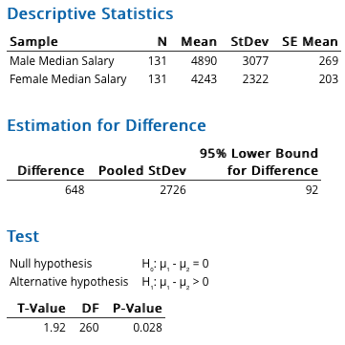 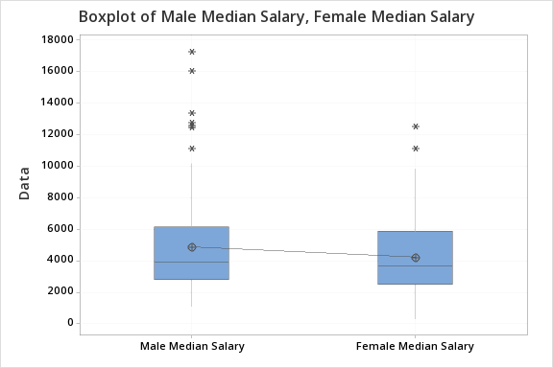

4890 4243 648 d.f. » 260 Test statistic = 1.92 P-value = 0.028

The 95% confidence bound for  is: > 92

**Conclusion**

Since P-value = 0.028 < a = 0.05, it is rare to get a difference of sample median Salary as extreme as 648, if the population mean difference is 0.

We are 95% confident that the population mean difference falls above 92, which does not inlude the claimed difference of 0.

Therefore, we reject H0 at a = 5%.

Hence, we can conclude that there is a difference in the average salary between male and female.

In summary, we are conclude that there is a gender income gap between male and female working adults. Despite government initiative to work on closing the gap, there is still room for improvement.

Reference:

<https://www.channelnewsasia.com/news/singapore/women-singapore-earn-6-per-cent-less-than-men-wage-gap-12247034>

<https://stats.mom.gov.sg/genderpaygap/index.aspx>

<https://www.randstad.com.sg/career-advice/career-development/what-women-and-men-can-do-to-close-the-gender-pay-gap/>

<https://data.gov.sg/dataset/average-mean-monthly-nominal-earnings-per-employee-by-sex-annual>